Actividades 1 y 2 de la página 70 y completar la siguiente tabla.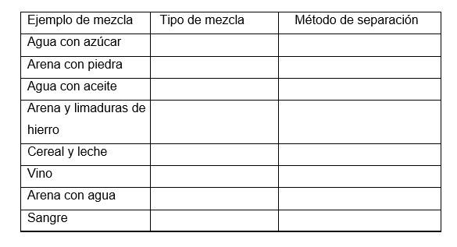

ANSWERS

1. Look at the photos and answer the questions.

a. Solids from liquids or solids with different sized particles.

b. Heat helps to speed up evaporation.

c. Liquid to gas and gas to liquid.

1. Listen and decide which method is best to separate these mixtures.

a. evaporation

b. distillation

c. filtration

1. Tabla:

|  |  |  |
| --- | --- | --- |
| Agua con azúcar | Homogeneous Mixture | Evaporation |
| Arena con piedra | Heterogeneous Mixture | Filtration |
| Agua con aceite | Heterogeneous Mixture | Distillation |
| Arena y limaduras de hierro | Heterogeneous Mixture | Magnetic separation |
| Cereales y leche | Heterogeneous Mixture | Filtration |
| Vino | Homogeneous Mixture | Distillation |
| Agua con arena | Heterogeneous Mixture | Evaporation |
| Sangre | Homogeneous Mixture | Distillation |